Variations of the Earth’s rotation observed by the space geodesy
-- The atmospheric excitation of the Chandler wobble ---

Isao Naito

Earth Rotation Division, National Astronomical Observatory

Summary. Variations of the Earth’s rotation observed by the space geodesy during the latest decades and their geophysical interpretations are reviewed in the seminar. Here only the studies of excitation of the Chandler wobble (CW) are summarized. Though variations of atmosphere plus ocean have been noticed widely as the most possible source (Celaya et al., 1999; Ponte and Stammer, 1999; Gross, 2000), Aoyama and Naito (2001) lately have shown using Japan Meteorological Agency (JMA) analysis data that atmospheric wind plus pressure variations can excite CW (also see Plag (1997)). Below are results of revisiting atmospheric excitations by using two analysis data of European Center for Medium-range Weather Forecast (ECMWF) and National Center for Environmental Prediction (NCEP). Quasi-14 month fluctuations in the atmospheric excitation function are found from ECMWF and JMA data for the 14 years of 1980-1993. In the vicinity of 14-month periodicity, spectra of the atmospheric wind excitation function show a striking peak (see upper panel of Fig. 1). As the result, the atmospheric (wind plus pressure) excitation functions show exactly same power as that of the geodetic excitation function inferred from the observed wobble at CW frequency (about 14 months), suggesting that the atmosphere excites CW. These wind fluctuations come mostly from the tropospheric wind. The same wind fluctuation is also found from NCEP data, but its power spectrum near 14-month periodicity shows too small to excite CW (see lower panel of Fig.1).

References
Aoyama, Y., and I. Naito, Atmospheric excitation of the Chandler wobble, 1983-1998, J. Geophys. Res., 106, 8941-8954, 2001.
Celaya, M. A., J. M. Wahr, and F. O. Bryan, Climate-driven polar motion, J. Geophys. Res., 104, 12813-12829, 1999.
Gross, R. S., The excitation of the Chandler wobble, Geophys. Res. Lett., 27, 2329-2332, 2000.
Plag, H.-P., Chandler wobble and pole tide in relation to interannual atmosphere-ocean dynamics, in Tidal Phenomena, Lecture Notes in Earth Sciences, 66, Edited by H. Wilhelm, W. Zurn, and H.-G. Wenzel, 183-218, Springer, Berlin, 1997.
Ponte, R. M., and D. Stammer, Role of ocean currents and bottom pressure variability on seasonal polar motion, J. Geophys. Res., 104, 23393-23409, 1999.

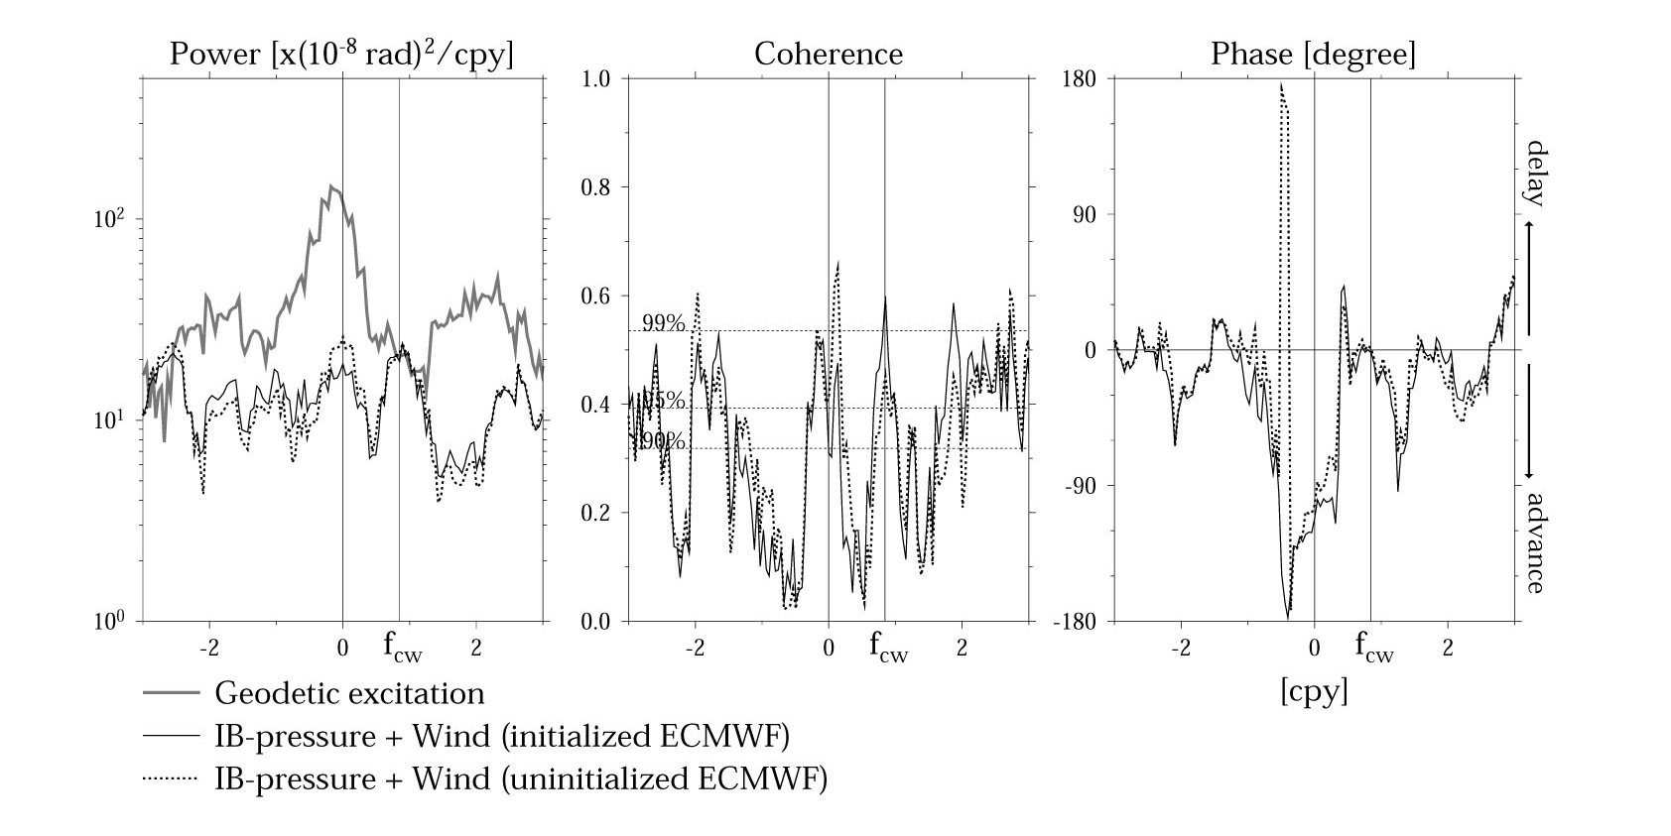
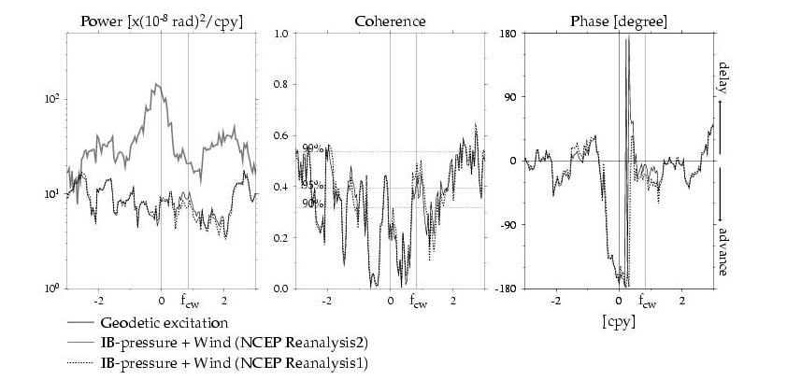

Figure 1. Power spectra, squared coherence, and phase difference of/between the geodetic excitation function from the polar motion data observed by the space geodesy and the atmospheric (wind plus IB-pressure) excitation functions from the atmospheric analyses data at frequency bands from –3 to 3 cpy for the 14 years of 1980-1993, where f_{cw} = 0.847 cpy and Q_{cw} = 179 of the Chandler wobble are assumed.
Upper panel: ECMWF data, Lower panel: NCEP data

